LWS Extreme Team Semi-Annual Meeting
Portsmouth, New Hampshire
Sheraton Portsmouth Harborside Hotel
October 22−24, 2019
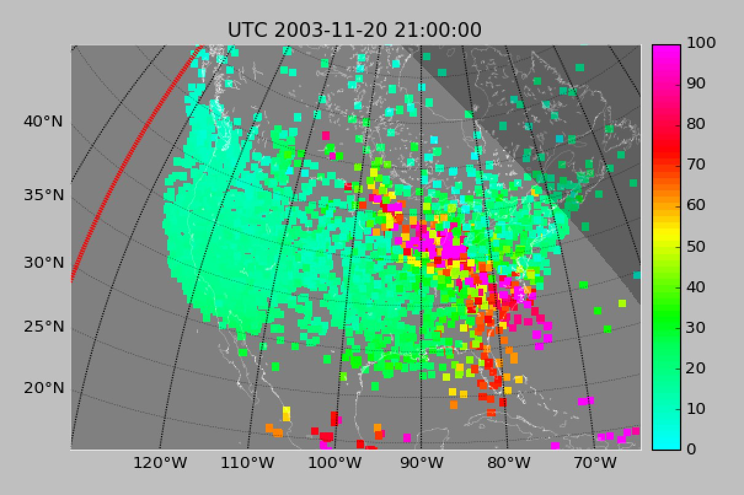

Storm enhanced density during the November 20, 2003 storm.
(Courtesy Shunrong Zhang and Anthea Coster)

LWS Extreme Team Semi-Annual Meeting
Portsmouth, New Hampshire
Sheraton Portsmouth Harborside Hotel
October 22−24, 2019
PROGRAM

 | Time | Title |  |  | Presenter
 | Tuesday, October, 22, 2019
 | Individual Reports
 | 0800-0900 |  | Breakfast Gardner Room
 | 0900-0920 |  | Introduction |  | Tim Fuller-Rowell
 | 0920-0955 |  | Understanding and Predicting the Space Weather Impact of Extreme Solar Storms |  | Jimmy Raeder
 | 0955-1030 |  | Quantifying Solar Wind-Magnetosphere-Ionosphere Response to Extreme Driving Conditions |  | Natalia Buzulukova
 | 1030-1050 |  | Coffee Break
 | Individual Reports continued
 | 1050-1125 |  |  | Data Mining for Extreme Space Weather | Misha Sitnov (remote call in)
 | 1125-1200 |  |  | Understanding the Thermosphere-Ionosphere Response to Extreme Solar Events | Fuller-Rowell and Naomi Maruyama
 | 1200-1215 |  |  | Satellite Drag Applications | John Emmert
 | 1215-1250 |  |  | Response of the Mesosphere, Thermosphere and Ionosphere to Extreme Solar Flare Events | David Siskind
 | 1250-1400 |  |  | Lunch Break outside Gardner Room
 | Individual Reports continued
 | 1400-1435 |  |  | Ionospheric Response to Super Storms and Its Role in Geospace Coupling | Anthea Coster
 | 1435-1510 |  |  | A Nighttime Ionospheric Localized Enhancement (NILE) at Midlatitudes during Extreme Storms | Seebany Datta-Barua
 | 1510-1545 |  |  | Conductance Effects on Global Magnetosphere-Ionosphere Evolution during Storms and Superstorms | Meers Oppenheim
 | 1545-1605 |  |  | Coffee/Tea Break
 | Individual Reports continued
 | 1605-1640 |  |  | Physics-Based Modeling of the Magnetosphere-Ionosphere-Thermosphere-Mesosphere System under Carrington-Scale Solar Driving: Response Modes, Missing Physics and Uncertainty Estimates | Sean Blake for Antti Pulkkinen
 | 1640-1715 |  |  | Quantifying Deep Penetration of Energetic Electrons and Ions in the Inner Magnetosphere during Extreme Storms | Suk-Bin Kang
 | 1715-1730 |  |  | Discussion | All
 | Dinner on your own
 | Wednesday, October 23, 2019
 | Guest Speakers and Team Plan 1
 | 0800-0900 |  | Breakfast Gardner Room
 | 0900-0910 |  | Introduction |  | Tim Fuller-Rowell
 | 0910-0940 |  |  | SAR Arcs and Mid-Latitude Energetics during Superstorms | Janet Kozyra
 | 0940-1010 |  |  | Quantifying Energy Flow during Superstorms | Dan Weimer
 | 1010-1030 |  |  | MIA Coupling Precipitation Electron Dynamics | George Khazanov
 | 1030-1050 |  |  | Coffee Break
 | Team Plan 1 ─ 20 November 2003 Event presentations
 | 1050-1055 |  |  | Introduction | Tim Fuller-Rowell
 | 1055-1110 |  |  | Presentation 1 | Shunrong Zhang
 | 1110-1125 |  |  | Presentation 2 | Additional MIT
 | 1125-1140 |  | Presentation 3 |  | Natasha Buzulukova
 | 1140-1155 |  | Presentation 4 |  | Alex Chartier
 | 1155-1210 |  | Presentation 5 |  | Tim Fuller-Rowell
 | 1210-1300 |  | Extreme flare presentations and discussion |  | Dave Siskind et al.
 | 1300-1400 |  | Lunch outside Gardner Room
 | Afternoon Tour and Team Dinner
 | Thursday, October 24, 2019
 | Step Forward for Team Plan 1 ─ Support for SWAP Benchmarks
 | 0800-0900 |  | Breakfast Gardner Room
 | 0900-0910 |  | Introduction ─ Next Steps Benchmarks |  | Tim Fuller-Rowell
 | 0910-0930 |  |  | SWAP Benchmark 5 ─ Upper Atmospheric Expansion | John Emmert
 | 0930-0950 |  |  | SWAP Benchmark 3 ─ Ionospheric Disturbances | Anthea Coster
 | 0950-1010 |  |  | SWAP Benchmark 1 ─ Induced Geoelectric fields | Peter Schuck for Antti Pulkkinen
 | 1010-1030 |  |  | Benchmark discussion / Overspill Extreme CME/Flares | All
 | 1030-1050 |  | Coffee Break
 | Team Planning/Update to Charter
 | 1050-1130 |  | Overspill Extreme CME/Flares Discussion |  | All
 | 1130-1300 |  | Team Planning/Update to Charter/Next Team Meetings/Web Page/Wiki/Google Docs/Session Planning/Joint Meetings/Data and Model Sharing |  | All
 | 1300-1400 |  | Lunch outside Gardner Room
 | 1400 |  | Meeting Ends

LWS Extreme Team Semi-Annual Meeting
Portsmouth, New Hampshire
Sheraton Portsmouth Harborside Hotel
October 22−24, 2019

PARTICIPANTS

 | First Name |  | Last Name |  | Institution |  | Email Address
 | Seán |  | Blake |  | Trinity College Dublin |  | bkakese@tcd.ie
 | Alex |  | Chartier |  | JHU/APL |  | alex.chartier@jhuapl.edu
 | Natalia |  | Buzulukova |  | NASA GSFC |  | nbuzulukova@gmail.com
 | Seebany |  | Datta-Barua |  | Illinois Inst Tech |  | sdattaba@iit.edu
Anthea |  | Coster |  | MIT Haystack |  | ajc@haystack.mit.edu
 | Yakov |  | Dimant |  | Boston Univ |  | dimant@bu.edu
 | John |  | Emmert |  | NRL |  | John.Emmert@nrl.navy.mil
 | Mei-Ching |  | Fok |  | NASA GSFC |  | Mei-Ching.H.Fok@nasa.gov
 | Tim |  | Fuller-Rowell |  | CU CIRES |  | Tim.Fuller-Rowell@noaa.gov
 | Larisa |  | Goncharenko |  | MIT Haystack |  | lpg@haystack.mit.edu
 | Joseph |  | Huba |  | NRL |  | joe.huba.ctr@nrl.navy.mil
 | Suk-Bin |  | Kang |  | Catholic Univ |  | suk.bin.kang.spacephysics@gmail.com
 | George |  | Khazanov |  | NASA GSFC |  | George.V.Khazanov@nasa.gov
 | Colin |  | Komar |  | NASA GSFC/CUA |  | Colin.M.Komar@nasa.gov
 | Janet |  | Koryza |  | NASA |  | Janet.Koryza@nasa.gov
 | Naomi |  | Maruyama |  | CU CIRES |  | Naomi.Maruyama@noaa.gov
 | Slava |  | Merkins |  | JHU/APL |  | Slava.Merkin@jhuapl.edy
 | Meers |  | Oppenheim |  | Boston Univ |  | meerso@bu.edu
 | Antti |  | Pulkkinen |  | NASA GSFC |  | Antti.A.Pulkkinen@nasa.gov
 | Jimmy |  | Raeder |  | UNH |  | J.Raeder@unh.edu
 | Peter |  | Schuck |  | NASA GSFC |  | Peter.schuck@nasa.gov
 | David |  | Siskind |  | NRL |  | David.Siskind@nrl.navy.mil
 | Mikhail |  | Sitnov |  | JHU/APL |  | Mikhail.Sitnov@jhuapl.edu
 | Wenbin |  | Wang |  | NCAR/HAO |  | wbwang@hao.ucar.edu
 | Daniel |  | Weimer |  | Virginia Tech |  | dweimer@vt.edu
 | Shunrong |  | Zhang |  | MIT Haystack |  | Shunrong@haystack.mit.edu

